Claims star schema model

Now you have new type of database. This model is known as a star schema model – note it is still a relational database model.

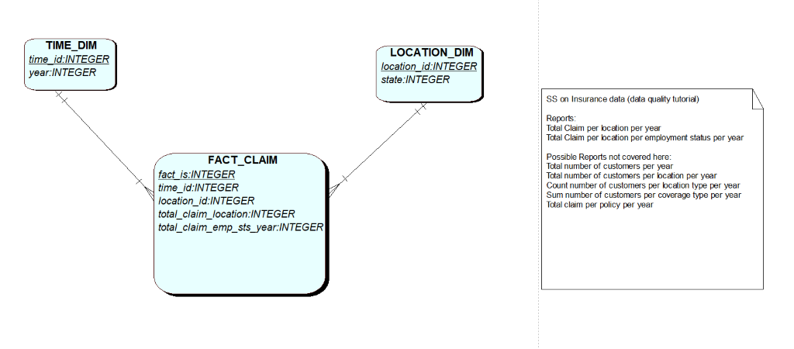

Run the Claims_SS script in apex and look at the data in each of the above tables.

Answer these questions:

* On the fact_claim table how many claims are there for Arizona in 2011?
* How many years of data does this database include?
* Are there any claims assigned to unknown states?

Now write SQL on the SS model to:

* SELECT the number of claims for 2011 in Arizona.
* SELECT the number of claims per state in 2011
* SELECT the number of claims per state per year